Working copy for discussion in fall 2013

Coastline Community College
Integrated Planning Guide
20123 - 20134
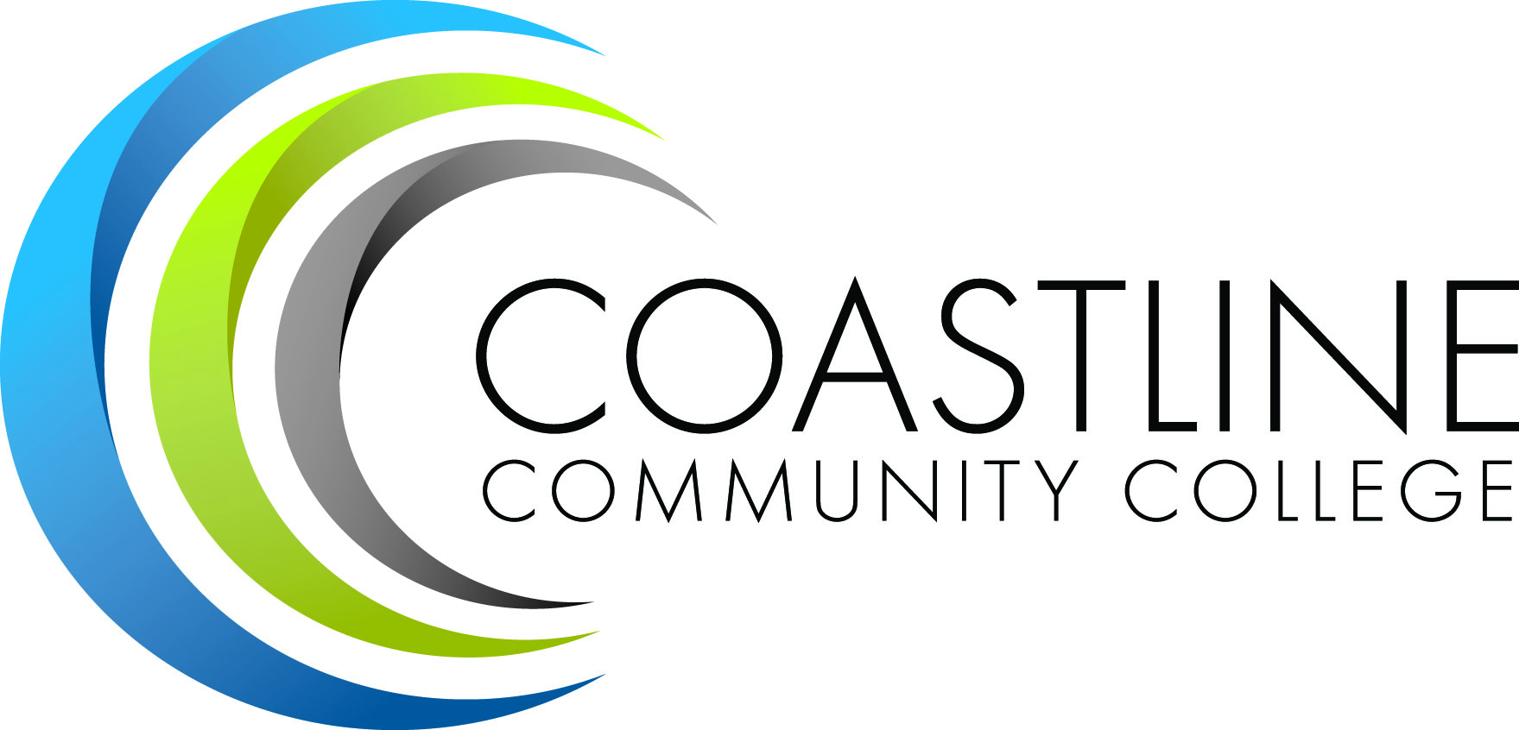
Prepared by
The Planning Institutional Effectiveness and Accreditation Committee
Spring 2012 Fall 2013

Vision Statement

Creating Opportunities for Student Success.

Mission Statement

Coastline Community College promotes academic excellence and student success for today’s global students through accessible, flexible, innovative education that leads to the attainment of associate degrees, transfers, certificates, basic skills readiness for college, and career and technical education.

Table of Contents

Overview Page 4

Planning Oversight - PIEAC Page 5

Planning Cycles & Processes Page 6

Primary and Secondary Plans Page 10

Links to Budget and Other Plans Page 12

Ongoing & Systematic Assessment of Key Performance Indicators Page 19

Collaborative/Participatory Inquiry Process Page 21

Evaluation of the Planning Process Page 22

Appendix A: ACCJC Rubric for Evaluating Institutional Effectiveness Page 23

Appendix B: Coastline Community College Goals 2011-2016 Page 26

Appendix C: Sample Action Plan Template Page 27

Appendix D: Sample PIEAC Resource Allocation Proposal Page 28

Glossary of Terms Page 35

Overview
Coastline Community College is guided by the principles of participatory governance and embraces a culture of learning, collecting evidence, and planning based on evidence. The college began the task of improving its planning process in 2010 with the renewal of the its Education Master Plan and the vision and mission statements. Then in
In 2011 the college continued this improvement effort by restructuring the framework for planning and data driven decision-making, in order to realize the goals of the College vision, mission, and Education Master Plan, including its Technology Plan, Staffing Plan, Facilities Plan, Program and Department Reviews, and the Student Learning Outcomes (SLOs) work being done in instruction, student support ,and administrative services wings of the college. Entrepreneurial efforts and other related matters that are applicable to the budget allocation model were also part of the restructuring.
The mandate (mission) and membership of the lead team, the Planning, Institutional Effectiveness, and Accreditation Committee (PIEAC), is identified in Section I. The members are expected to participate in review and discussion of institutional planning and to take information back to their constituency groups for discussion and feedback. All constituency groups are represented within PIEAC. Balance of the committee membership and assessment of the committee mandate will be ongoing and will be evaluated on an annual basis.
This guide is designed and developed by the PIEAC. It offers details on the planning processes at Coastline Community College. The purpose of the guide is to document the planning framework the college has adopted for integrated planning. The guide is intended to be used by all constituent groups on campus to assist in linking planning and decision making in a more integrated and meaningful manner.
This planning guide contains seven critical components of the planning process:
- The planning oversight group and this group’s its planning responsibilities.
- The various integrated planning processes and coordinating timelines and cycles.
- A description of both primary plans and secondary plans, and procedures used for completing these plans.
- Details on how the various plans link to budget decision-making.
- An inventory of key performance indicators used to evaluate the progress made on the college-wide goals and initiatives.
- A list of concrete strategies for engaging and informing the college community in the planning process.
- A plan for how the planning process will be regularly evaluated.

- PLANNING OVERSIGHT – PIEAC
Mission

To provide oversight and leadership in support of institutional effectiveness, and, through ongoing intentional College-wide evaluation, dialogue, planning , coordination, and use of systematic data to ensure student learning, ensure the college fulfills its mission and meets or exceeds institutional and accreditation standards. PIEAC reports, informs, and seeks approval from College Council.

Membership
- Academic Senate President, Co-Chair PIEAC and Budget Committees
- Academic Senate Vice President
- Accreditation Liaison (faculty)
- Classified Senate President
- Classified Senate Vice President or designee
- Classified Senate representative
- Dean, Instruction
- Dean, Instruction
- Dean, Instruction
- Dean, Counseling & Matriculation
- Dean, Enrollment Services
- Dean, Military & Contract Education or designee
- Executive Dean, Office of Learning & Information Technology, or designee
- Faculty – SLO Coordinator
- Faculty – Program Review
- Faculty – Part-time
- Faculty – Counseling
- Faculty – Curriculum
- Faculty – CTE
- Faculty – Technology/DL
- Faculty – General Education
- Faculty – General Education
- Faculty – Basic Skills/ESL
- Faculty – Special Programs
- Coastline President or designee
- Associate Dean, Research, Planning and Institutional Effectiveness
- Research, Analyst
- Technology Director (when position filled)
- One Stop representative
- ASG President or designee
- Vice President Administrative Services, Co-Chair Budget Committee
- Vice President Student Services
- Vice President Instruction & Student Services, Accreditation Liaison Officer (ALO), Co-Chair PIEAC Committee

- PLANNING CYCLES & PROCESSES
Planning at Coastline comprises a planning cycle with linked plans and decision-making processes. Each is described briefly in this section of the guide with details about each and the various steps, timelines and procedures described in Section IV of this guide.

Education Master Plan Development
The planning and decision making process for Coastline is dependent on the objectives, goals, initiatives, and key performance indicators established in the Education Master Plan. Development of the Education Master Plan occurs on a six-year cycle with input from and participation by the entire College (see figure #1). The Education Master Plan guides priorities, decisions, and recommendations from committees and constituency groups to College Council. The College Council also relies on the Education Master Plan in making final recommendations to the College President. The President, in making decisions and informing the College, also relies upon the Education Master Plan (see table 1).

Figure #1
Long and Short Term Planning Cycles

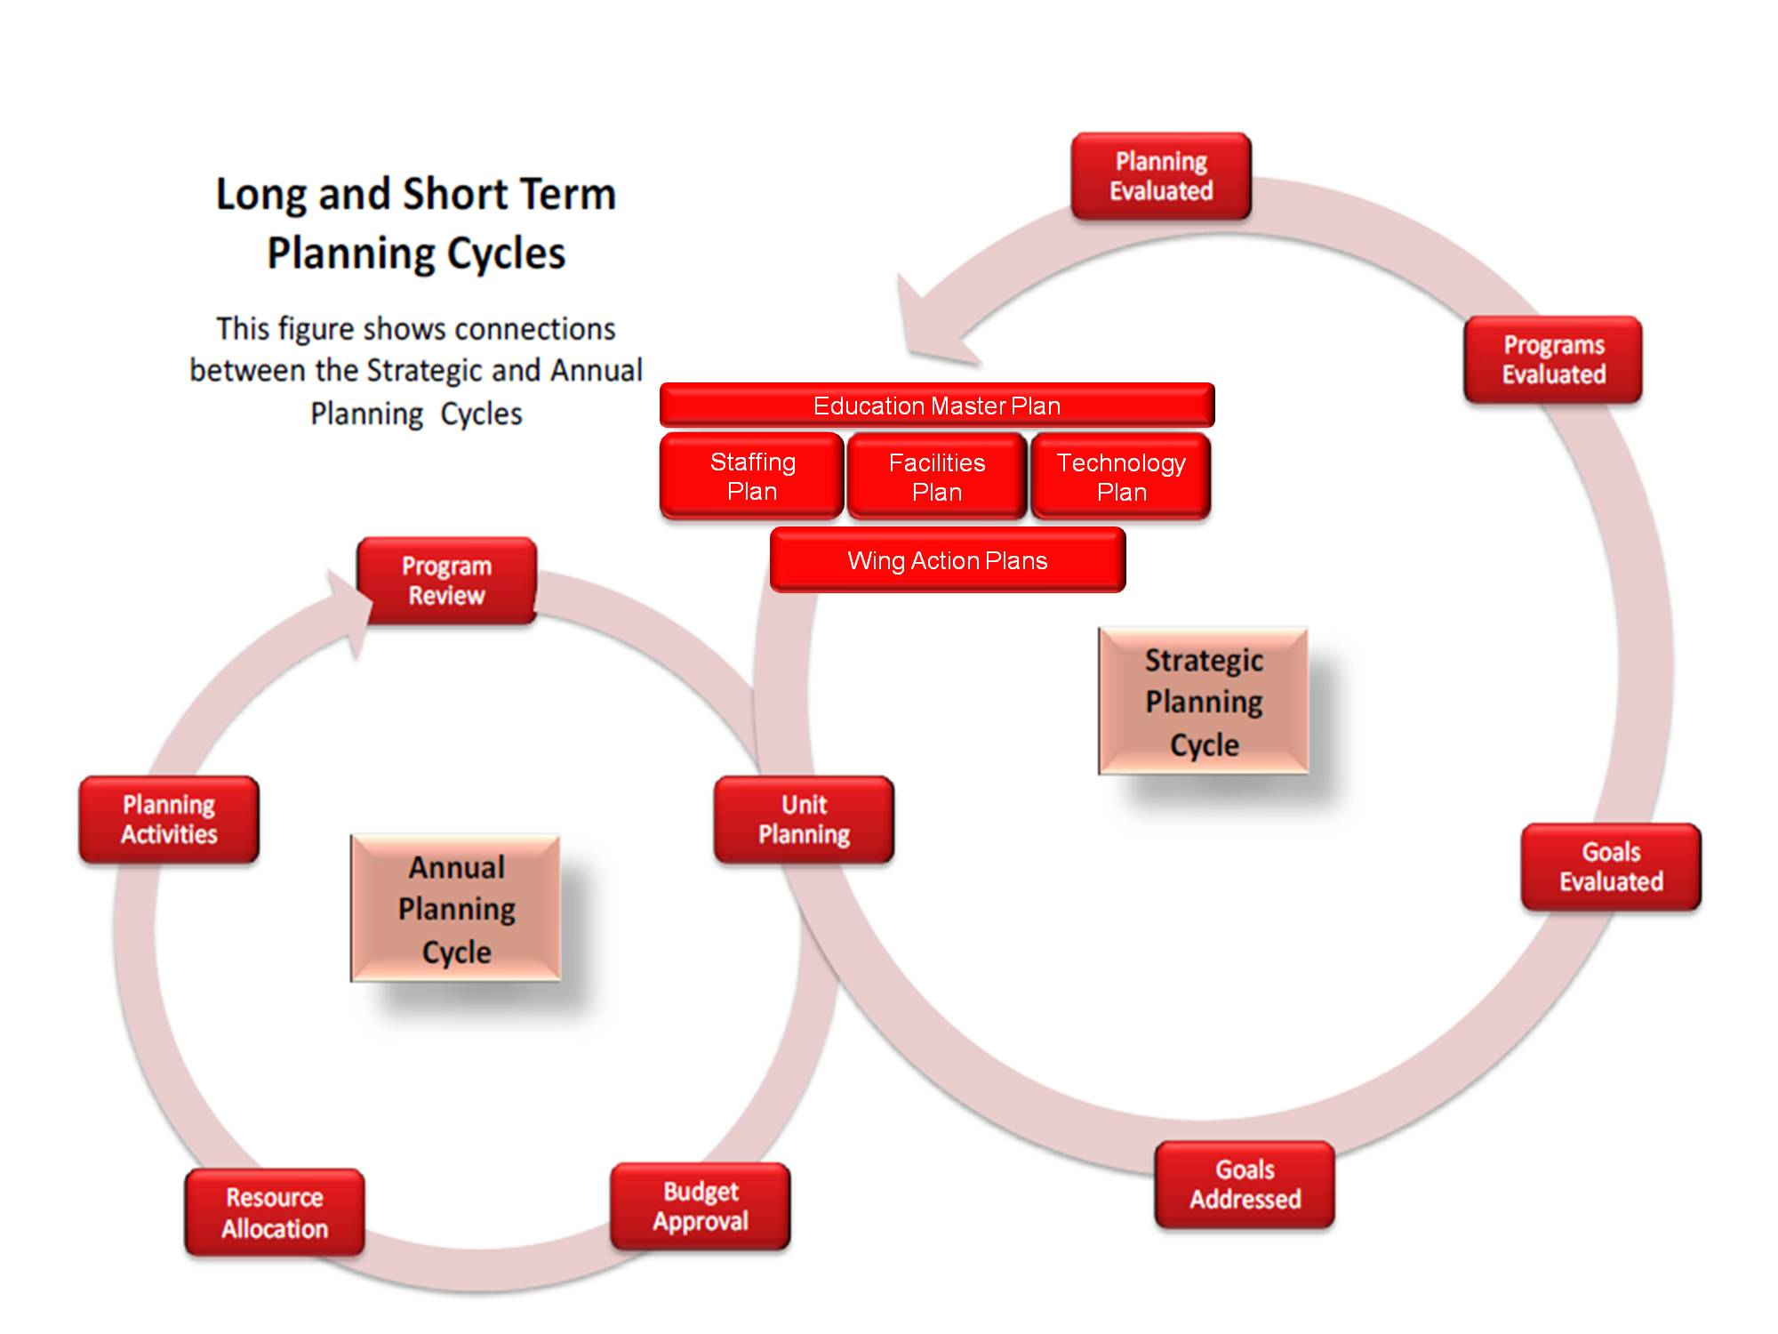

Annual Planning Cycle
Although Education Master Plan development occurs on a six-year cycle, there are also annual planning processes that occur within each wing of the college and the various departments (see figure #2).

A cCritical aspect elements of the planning and decision making processes are program review validation reports and annual updates department and program reports. The Program Review Committee ensures that program goals and priorities align with the Education Master Plan. In-depth review of each program occurs every 5 years with annual reports providing updates and information about new trends, events, or changes impacting the program.

Figure #2

Annual Planning Process
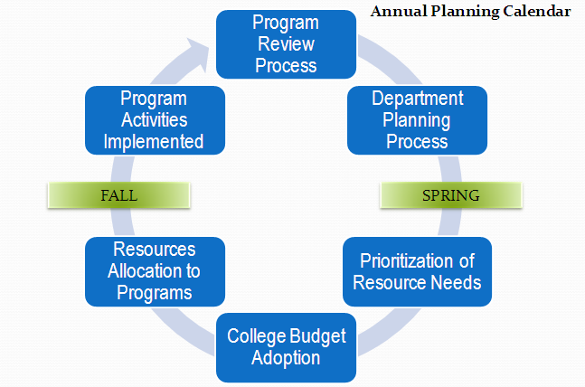

Planning, Institutional Effectiveness, and Accreditation Committee (PIEAC)
This committee leads the development of College goals, initiatives, programs, and projects, and makes recommendations to the President through College Council regarding college priorities and budget allocations.

Although most requests and information may come from the Program Review Committee, the Wings, the Office of the President, or any group or individual may advocate to PIEAC for their program or project.

Budget Process
The Budget Committee relies on prioritization that is established by PIEAC to match funding for programs, initiatives, projects, and services with available financial resources.
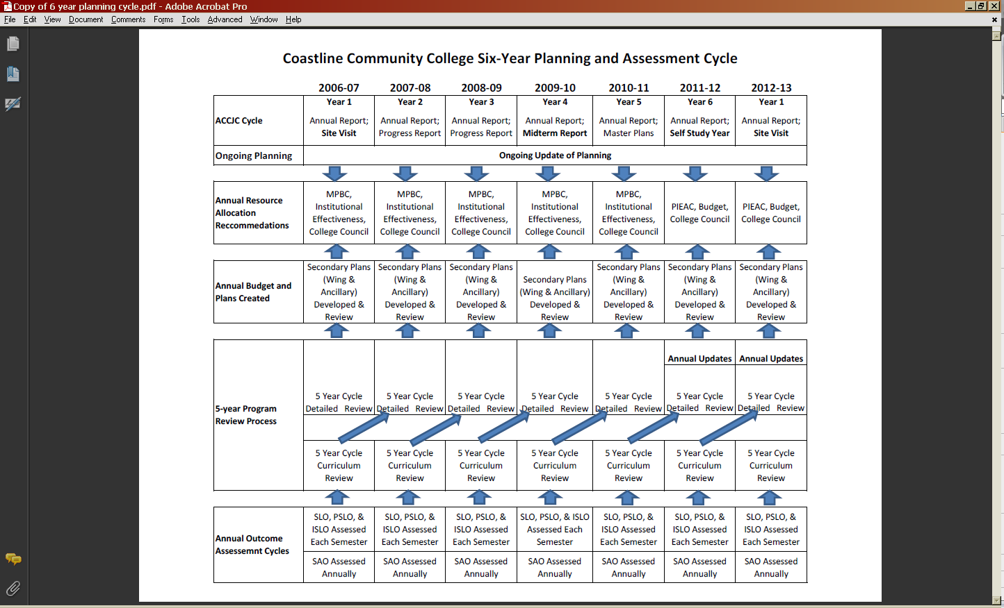
Table #1
Six year planning cycle
Planning Timelines

 | Strategic Master Planning Cycle (6-year cycle)
Table #2
Year one of planning calendar
- Assess current college status
- Conduct environmental scan for both internal trends, including labor market; employment and competitor trends; community, county and statewide demographic trends, political, social, educational and technological trends; and college enrollment trends
- Review program and support services recommendations
- Assess recommendations for new courses, programs, and services
- Develop and analyze enrollment scenarios and projections
- Establish college-wide goals, initiatives, and key performance indicators
Table #3
Year two-six: annual planning calendar
 | November . |  | Stakeholders give input, review plan, and make recommendations about strategies and success factors.
 | February |  | Strategies and success factors are presented to College Council and PIEAC.
 | March |  | PIEAC holds town halls and public forums.
 | April |  | PIEAC and College Council determine strategies and success factors for next year’s budget.
 | May |  | College Council finalizes budget for next fiscal year, dollars matched to strategies.
 | May |  | Annual plan includes goals, strategies, and success factors
 | July |  | New fiscal and planning year begins.

III. PRIMARY AND SECONDARY PLANS
Primary Plans
District Education Master Plan - The planning committee for the District Vision 2020 Plan was led by an outside consultant group; it consisted of representatives from all constituent groups, the three colleges, and the district.
Coastline's Education Master Plan - The development of the most recent Education Master Plan was led initially by the Research and Planning Group (RP Group) and then directed by the Planning, Institutional Effectiveness, and Accreditation Committee (PIEAC) in 2011. The Education Master Plan used information gathered from all constituency groups via forums, workshops, and surveys and used information gathered from the 5-year Program Reviews self-studies and , secondary Pplans, and annual program/department reports. Although the Master Plan is written on a six-year cycle, it is reviewed and updated on a yearly basis as needed. The Education Master Plan reflects the college mission, establishes Coastline standards, and contains conveys the College's priorities (as objectives, goals, and initiatives).
Program/Departmental Reviews - The program and departmental self-studies/plans annual reports feed directly into the college Education Master Plan and include program/department reviews from academic programs and service areas such as Administrative Services and Student Services, Financial Aid, Student Government, and also ancillary programs such as contract education, the economic development programs under the Coastline Institute for Economic Development, the Foundation, and the Office of Learning and Instructional Technology (OL&IT). Program/Department Review includes Student Learning Outcomes and Service Learning Outcomes as well as program goals, initiatives, and resource needs..
Coastline currently has three Wings: Administrative Services, Instruction & Student Services, and President Services. Each wing is ultimately responsible for the Program/Department plans underneath it. Each Wing leader presents Wing prioritizations and resource requests to PIEAC during the spring semester.
ll Wing and ancillary needs relate to the Master Plan and are developed from the Program/Department Reviews.
All wing and ancillary requests for resources should be relate to the Master Plan goals and initiatives, and supported through evidence from the Program/Department Reviews.

Secondary Plans
The following secondary wing plans are college plans that receive input from all programs and departments through the appropriate Wing.
Instruction and Student Services
- Enrollment Management Plans
- Matriculation Plans
- Outreach Plans
- Student Success Plans
- Professional Development Plans
- Instructional Programs and Services
- Student Equity Plan
- Technology Needs
- Categorical Program Plans
- Grants
- Military/Contract Education

Administrative Services
- Staffing Plan (Faculty, Classified, and Managers)
  - This includes hiring of new staff as well as re-organization of staff.
- Facilities Plans
- Technology Needs
- Marketing Plan
- Grants
- Ancillary Units - Include, but not limited to: OL&IT, Foundation, Contract Ed/Military, Coastline Institute for Economic Development
- Marketing
- Outreach
- Technology

Entrepreneurial Endeavors
- Partnerships
- Innovative Concepts
- Grants

- LINKS TO BUDGET AND OTHER PLANS
The Education Master Plan is the basis for all planning within the college. The plan was created, vetted, and approved by the entire college during the 2010-2011 academic year and is integrated into all other planning functions within the college. Objectives and goals derived from the Facilities Plan and the Technology Plan are to be incorporated into the overall plan to provide seamless integration of the planning process. The goals and initiatives in the Education Master Plan are provided to all programs and departments for use in their particular planning components.
PROGRAM REVIEW
Planning-The Education Master Plan goals and initiatives are sent to the programs and departments at the beginning of the Program Review self-study process (see figure #3). During this time, discussions can take place to review the current plans and directions of the program/department and provide ample time to restructure programs and design/redesign curriculum and programs to address these objectives and goals. By reviewing and addressing these goals prior to beginning the program review cycle, the goals and objectives Education Master Plan becomes completely integrated into the program/department self-study process.
Data Gathering-The pA program/department self-study begins in the spring semester, and includes
- documentation of evidence; needs assessments;
- curriculum updates;
- surveys of students, faculty, staff, and administrators;
- business and industry partner advisory comments and recommendations;
- review of Program/Course Student Learning Outcomes, assessment and revision;
- facility needs;
- staffing needs; and
- any additional items that could potentially require resource allocation.

Outcome data will be collected at the end of each fall semester by all disciplines, programs, and departments, whether they are going through the self-study cycle or the annual report cycle. The outcomes from student assessment will be discussed by discipline faculty at the spring faculty meeting. Discussions will center on student achievement of SLOs/PSLOs/ISLOs as they relate to the Education Master Plan goals, and adjustment to these goals and outcomes will be made to ensure student success. Service and administrative departments will undertake a similar discussion regarding service area outcomes (SAOs) during the summer or early in the fall semester.
Writing Phase-During the fall semester summer following the program review spring preparations for the self-study preparation year, the program/department prepares and writes its Program Review ReportSelf-Study, outlining the findings from the data gathering cycle, reviewing the current structure and goals, and then preparing an action plan and resource allocation predictions for both the following year and the next five years. Each of these planning documents should link to a specific Master Plan objective or goal with justification for resource allocation needs. As part of the writing phase, evaluation of the program review process should be assessed in terms of relevance, efficiency, and ways to improve the process, thus providing a true reflection of the process. A final copy of the Program/Department Self-Study shall be submitted to the Instructional Dean or Department Manager for inclusion in Wing planning and budgetary request preparation. The original self-study shall be submitted to the Program Review Committee during the fall semester.

Figure #3
Program Review Process

Presentation-During the fall semester the final self-study report is submitted to the Program Review Committee which carefully evaluates the report in order to validate its claims and resource needs. following the program review preparation year, The program/department meets with the Program Review Committee to discuss any issues, concerns, questions, and commendations the Committee may have prior to validating the report. , outlining its review of its current structure and goals as well as the new five-year goals and objectives. These new goals and objectives as well as the planning documents developed during the writing phase are presented, showing links to the Education Master Plan

Annual Report-For those programs/departments not engaged in the five-year Program Review self-study cycle, an annual report will be completed by the end of October to the Program Review Committee for evaluation and validation. These reports include action and resource allocation plans showing any needs that may require funding from the budgetary process and the justification based on Education Master Plan Objectives, Goals, or Initiatives .
Data Passed to Planning-By the middle of November, all Annual Reporst and Five-Year Resource Plans and Allocation Predictions will be sent to College Council for review and then housed in the Office of Instruction with a copy being presented to the Chair of Planning, Institutional Effectiveness and Accreditation Committee (PIEAC) for use in discussions and planning prior to sending resource requests to the Budget Committee.
Conclusion of the Program Review Cycle – Before the end of the fall semester, the Program Review Committee will prepare a summary report of all 5-year self-studies and annual reports to present to Wings managers and to PIEAC.
Major topics of interest to the entire college shall be considered for further vetting through various avenues including brown bag lunches and town hall gatherings.

PLANNING, INSTITUTIONAL EFFECTIVENESS AND ACCREDITATION COMMITTEE
Data Gathering-During the fall semester, the PIEAC gathers data from the college in the form of Education Master Plan Objectives and Goals , Facilities Plan Goals, Technology Plan Goals, District’s 20/20 plan, Chancellor’s directives, Legislative directives, College President’s directives, Grant Team ideas and proposals, and budget information from Administrative Services. At the end of the fall semester, PIEAC also receives the Program Review Summary Report.
Strategic Planning-
During the month of November, Wing Planning Councils will convene in order to prepare presentations that will be made to PIEAC during February. The Wing Planning Councils will have broad representation from within the Wing and will prepare a report that includes Wing objectives and goals, priorities, resource needs, and allocation requests.
Each Wing will present its report to PIEAC during the month of February so that PIEAC can complete its institutional prioritization process during its first meeting in March. The institutional prioritization plan will be forwarded to College Council for consideration and to the college Budget Committee for allocation recommendations.

Conclusion of the PIEAC Planning Cycle After the Budget Committee has deliberated and matched resource requests with funding sources, it will return its report to PIEAC which then forwards the recommendations to College Council for final budget approval. College Council forwards the budget recommendations directly to Administrative Services by April 15 for development of the college budget. Administrative Services will submit the proposed budget to the college president in timely fashion, and will forward a copy of the budget to PIEAC as an information item for dissemination to college constituency groups.

Figure #4
PIEAC Decision-making Process

Planning for Next Year-In late spring, using the Education Master Plan as the starting point for discussions related to strategic planning, the PIEAC develops goals/objectives for the following year. These goals/objectives are sent to the Academic Senate, Classified Senate, Student Associated Government, and Blue Ribbon Management Team for discussion and approval.
Town Halls/Forums-Following approval from constituency groups, PIEAC will hold town hall meetings to share the goals/objectives that have been approved and to get feedback and buy-in from the college as a whole.
Revision of Plans-Utilizing the feedback from the town hall meetings and constituency group discussions, the PIEAC reviews and approves the annual goals/objectives and sends them to College Council.
New Ventures for Consideration-When new ideas for programs or projects arise, the ideas will be discussed at length within the wing that will host the program or project to determine the relevance to the Mission Statement and/or Vision Statement, costs associated with the project in terms of budgetary items and personnel costs, curriculum development required, and implementation timeline. Once the plans for the new program or project have been discussed and approved by the participants to be within the Mission of the college, the plan will be taken at any time of year to PIEAC for discussion and possible referral to the Budget Committee and College Council. If PIEAC determines that the program/project aligns itself with the Mission Statement, PIEAC will forward the program/project plans to College Council for discussion and approval. The outcome from the discussions at College Council will be sent to PIEAC and the Budget Committee for information and budgetary consideration. Funding for the new program or project will need to be addressed during the budgetary process or if out of cycle, at the time of acceptance. Following approval at PIEAC, the constituency representatives will take the program/project idea back to their constituencies as an informational item.
BUDGET COMMITTEE
Data Gathering-Administrative Services collects input from the various wings about specific resource allocation needs that have surfaced since the last budget cycle. provides the committee with budget information and funding sources.
PIEAC Directives-The Budget Committee and Administrative Services receive the prioritizations from PIEAC The Budget Committee is charged with making recommendations regarding funding sources matched to resource needs/requests. The Budget Committee may recommend full, partial, or no funding depending upon the resource priority as established by PIEAC.
Budget Rollover-Administrative Services takes the budget from the prior year and rolls it over to begin the budget process. Administrative Services reviews the directives/prioritization from PIEAC, Wing resource augmentation requests, current budget predictions from the District and directives from the College President and determines whether there are ample recourses available to meet these requests and reports back to the Budget Committee. If the funds are not sufficient to meet the needs of the requests, the Budget Committee sends a request for clarification of needs to the PIEAC. PIEAC will respond with a recommendation prioritizing directives that request budgetary expenditures.

Figure #5
Budget Process

Budget Development-Administrative Services works with the Wings to develop balanced budgets based on the directives of the PIEAC. Budget recommendations are presented to Budget Committee in the spring.
Budget to College Council-The final budget is sent to College Council for discussion and then is forwarded on to the College President for approval and implementation.
Ending Balance Requests-Each Wing will develop a prioritized list of requests for ending balance funds based on the Education Master Plan goals and initiatives as well as the yearly strategic plans. These requests will be combined and prioritized during the March PIEAC meeting. Funding approval for summer expenditures will be completed at the last May April meeting with final disbursement for the remaining requests to be completed in the fall after the final budget is approved.

Adjustments after Ending Balance is Finalized - In October of the following year, the Vice President of Administrative Services will provide final ending balance data to PIEAC and Budget Committee. Budget committee will review the information to consider recommendations to increase ending balance resource allocations funding if there are significant increases in the actual ending balance. If the Budget Committee recommends increasing funds available for resource allocations requests from the prior year, additional expenditure will be based on prioritization from the prior year.

Month | Activity
June/July | Summer
August | Summer
September | - Review mandate and charge for PIEAC.  - Orientation for new members.  - Review the Educational Master Plan and other college plans.  - Track progress on achieving goals and objectives  - Establish a task force to review the college mission and vision statements (every even fall semester).  - Receive updated college statistics and external data.  - Create a plan of work for the school year, including presentations from programs, departments, and other groups through the fall semester.  - Develop a planning calendar and distribute college-wide.  - Review previous year’s budget report, including ending balance reports for general and ancillary funds.  - Review unfunded requests from previous year and forward additional resource allocation recommendations, if applicable, to the Budget Committee.
October | - Final ending balance updated provided to PIEAC and Budget Committee.  - Ending balance funding increases considered by PIEAC and Budget Committee.  - Review final additional resource allocations and forward to College Council and President.  - Enrollment management report.  - Update on funded current year one-time requests.  - Review and modify, if necessary, identified Key Performance Indicators.
November | - Semi-annual update on general and ancillary operations.  - Finalize review of mission and vision statements (every even fall semester).
December | 1. Institutional Effectiveness Report  2. Hold public forum and/or town hall.
January | Intersession
February | - Receive report from Program Review (first meeting in spring).  - Receive 3 Wing plan presentations.  - SLO’s assessment reports.
March | - Prioritize resource requests based on Wing input, stakeholder concerns/issues, and recommendations from Program Review (1st meeting in March).  - Submit prioritized resource request to the Budget Committee which returns allocation recommendations to PIEAC (2nd meeting in March).  - PIEAC reviews and approves recommendations from Budget Committee, and forwards them to College Council (by the end of March).
April | - College Council approves the recommendations and forwards them to Administrative Services for development into a proposed budget.  - Administrative Services submits the proposed budget to the president for final approval; a copy of the tentative budget is sent to PIEAC as an information item.  - Analyze and discuss the Institutional Effectiveness score card and prepare IE summary report.  - Review and evaluate PIEAC processes and revise as necessary.  - Present IE report to Academic Senate, Classified Senate, and Blue Ribbon Management Team.
May | Emergency meetings only

V. Ongoing and Systematic Assessment of Key Performance Indicators
The plan will contain a set of key performance indicators that will be regularly measured, benchmarked, tracked, and mapped to annual strategic initiatives and goals. These are reported in college-wide outcomes via a Coastline Community College Scorecard so improvement may be made and plan adjusted.
Figure #6
Sample - Coastline College Strategy Map
Domains | Goals | 2012/13 Strategic Initiatives | Key Performance Indicators
Student Success | 1. Coastline will make learner success its core focus. | Strategic Initiatives which align with individual goal will be listed.  1.1  1.2 | - Number of Awards Conferred  - Transfer Volume  - Transfer Rates  - Successful Course Completion Rates  - ARCC Basic Skills Improvement Rates
Access, Persistence,  & Retention | 2. Coastline will increase student access, and improve persistence and retention with a particular focus on basic skills. | Strategic Initiatives which align with individual goal will be listed.  2.1  2.2 | - Fall to Fall Persistence Rates  - Retention Rates  - Basic Skills Retention Rates  - Subsequent Success of Basic Skills
Innovation & Improvement | 3. Coastline will continue to create and nurture innovative programs, services and technology solutions that respond to the needs and expectations of its learning community. | Strategic Initiatives which align with individual goal will be listed.  3.1  3.2 | 1. Program Review Completion Rate  2. Overall Student Satisfaction Ratings  3. Percentage of Fully Online Programs  4. Number of CTE Certificates
Partnerships | 4. Coastline will strengthen and expand its entrepreneurial, grant development and collaborative activities through partnerships with business and industry, government agencies, educational institutions, and the public to enhance the college’s capabilities and opportunities for students. | Strategic Initiatives which align with individual goal will be listed.  4.1  4.2 | 1. Number of Partnerships  2. Number of Articulation Agreements  3. Amount of Grants Received
Culture of Planning, Evidence, & Inquiry | 5. Utilizing participatory governance processes, Coastline will improve its collection, analysis and use of data to enhance teaching, learning and institutional effectiveness. | Strategic Initiatives which align with individual goal will be listed.  5.1  5.2 | 1. Overall Employee Satisfaction Ratings  2. Number of Data-driven Events  3. Fill Rates  4. Load (WSCH/FTEF)  5. Percent within FTES Cap
Growth & Efficiency | 6. Coastline will purposefully advance and sustain the college’s capacity for student success through efficient use of resources, as well as expanded diverse and responsive programs and services. | Strategic Initiatives which align with individual goal will be listed.  6.1  6.2 | 1. Number of Programs for Underrepresented Student Groups  2. Number of Professional Development Training

Figure #7
Sample - Coastline Community College Scorecard
Benchmarks |  | Outcomes | Fully Met | Partially Met | Not Met
STUDENT SUCCESS
 | Number of Awards Conferred
 | Transfer Volume
 | Transfer Rates
 | Successful Course Completion Rates
 | ARCC Basic Skills Improvement Rates
Access, Persistence & Retention
 | Fall to Fall Persistence Rates
 | Retention Rates
 | Basic Skills Retention Rates
 | Subsequent Success of Basic Skills
 | Student Demographic Representation
Innovation
 | Program Review Completion Rate*
 | Overall Student Satisfaction Ratings
 | Percentage of Fully Online Programs
 | Number of CTE Certificates
Partnerships
 | Number of Partnerships*
 | Number of Articulation Agreements*
 | Amount of Grants Received*
Culture of Planning, Evidence, & Inquiry
 | Overall Employee Satisfaction Ratings
 | Number of Data-driven Events*
 | Fill Rates
 | Load (WSCH/FTEF)
 | Percent within FTES Cap
Growth & Efficiency
 | Number of Programs for Underrepresented Student Groups*
 | Number of Technology-related Professional Development Trainings*
*Lead Indicator: A descriptor or measure that is used to influence or predict future performance/results. Compare to Lag Indicators which describe past performance/results.

- Collaborative/Participatory Inquiry Process

The planning processes at Coastline are intended to be inclusive with multiple opportunities for all constituency groups to participate, dialogue, and provide input. Some of the strategies are listed here:
Strategies
  - All PIEAC meetings will be open to the college community, and members of the community are encouraged to attend, especially in the spring when prioritization and budget discussions take place.
  - All Program Review summaries will be available online to the college community.
  - Each constituency group will be responsible for discussion and exchange of information and ideas during the Wing Planning Council planning process.
  - All PIEAC reports will be posted online during the prioritization and budget process.

  - Members of PIEAC will share planning infrastructure and processes with their respective constituency groups, gathering input and feedback for PIEAC to make ongoing modifications.

Communications of Planning Process
At the beginning of each academic year PIEAC will send out the planning time line college-wide. PIEAC will maintain a page on the College websitethat will include agendas and minutes, the planning time line, notices of special meetings and town halls, and notes from discussions that takes place at special meetings and town halls. In addition, there will be a bulletin board for web discussion. As each milestone approaches, a notice will be sent out including ways to provide input participate into the process.

VII. Evaluation of the Planning Process

The planning process will be evaluated as follows:
  - Survey planning committee members (see sample survey questions)
    - Survey will be deployed mid-spring to record self-evaluation of committee and member effectiveness
    - Survey will be deployed via Survey Monkey
    - Results will be made available to committees in summary form in late spring
  - Track completion (% completed) of planning initiatives and activities
    - Report completion of activities and initiatives mid-spring
  - Committees will evaluate and revise committee goals/objective for the year
    - Results and comments will be collected via Year-End Progress Summary Report
    - Information will be incorporated in upcoming year goals and initiatives
  - Survey the College community to determine satisfaction with planning process and participation in the planning process
    - Survey all employees every three years

Sample Survey Questions:
- Select your position (Co-Chair or Member) in this Committee or Task Force.
- How well do you understand the charge of your committee or task force?
- Please rate the usefulness of the charge in directing the work of the committee or task force.
- How satisfied are you with the progress your committee or task force has made towards fulfilling its charge over the course of the year?
- How adequate is the membership structure of your committee / task force?
- How adequate is the size of your committee / task force?
- If you asked other people outside the committee for their expertise/input, how effective was this process?
- How effective was the communication within your committee or task force?
- How effective was the communication between you and the group you represent (both directions)?
- How effective was the communication between you and the College Planning Council?
- If you attended the orientation for co‐chairs, how well did it help you to be effective in your role? (for co‐chairs only)

Appendix A

ACCJC Rubric for Evaluating Institutional Effectiveness – Part II: Planning

Accrediting Commission for Community and Junior Colleges
Rubric for Evaluating Institutional Effectiveness – Part II: Planning

Levels of  Implementation | Characteristics of Institutional Effectiveness in Planning  (Sample institutional behaviors)
Awareness | • The college has preliminary investigative dialogue about planning processes.  • There is recognition of case need for quantitative and qualitative data and analysis in planning.  • The college has initiated pilot projects and efforts in developing systematic cycle of evaluation, integrated planning and implementation (e.g. in human or physical resources).  • Planning found in only some areas of college operations.  • There is exploration of models and definitions and issues related to planning.  • There is minimal linkage between plans and a resource allocation process, perhaps planning for use of "new money"  • The college may have a consultant-supported plan for facilities, or a strategic plan.
Development | • The Institution has defined a planning process and assigned responsibility for  implementing it.  • The Institution has identified quantitative and qualitative data and is using it.  • Planning efforts are specifically linked to institutional mission and goals.  • The Institution uses applicable quantitative data to improve institutional effectiveness in some areas of operation.  • Governance and decision-making processes incorporate review of institutional effectiveness in mission and plans for improvement.  • Planning processes reflect the participation of a broad constituent base.
Proficiency | • The college has a well documented, ongoing process for evaluating itself in all areas of  operation, analyzing and publishing the results and planning and implementing  improvements.  • The institution's component plans are integrated into a comprehensive plan to achieve  broad educational purposes, and improve institutional effectiveness.  • The institution effectively uses its human, physical, technology and financial resources to  achieve its broad educational purposes, including stated student learning outcomes.  • The college has documented assessment results and communicated matters  of quality assurance to appropriate constituencies (documents data and analysis of  achievement of its educational mission).  • The institution assesses progress toward achieving its education goals over time  (uses longitudinal data and analyses).  • The institution plans and effectively incorporates results of program review in all areas of  educational services: instruction, support services, library and learning resources.  • Program review processes are ongoing, systematic and used to assess and improve  student learning and achievement.
Sustainable  Continuous  Quality  Improvement | • The institution uses ongoing and systematic evaluation and planning to refine its key processes and improve student learning.  • There is dialogue about institutional effectiveness that is ongoing, robust and pervasive;  data and analyses are widely distributed and used throughout the institution.  • There is ongoing review and adaptation of evaluation and planning processes.  • There is consistent and continuous commitment to improving student learning;  and educational effectiveness is a demonstrable priority in all planning structures and processes.

Appendix B

Coastline Education Master Plan Goals 2011-2016

Goal 1- Student Success: Coastline will make student success its core focus
Goal 2 - Access, Persistence, and Completion: Coastline will increase student access, and improve persistence, retention, and completion with a particular focus on Basic Skills.
Goal 3 – Innovation and Improvement: Coastline will continue to create and nurture innovative programs, services, and technology solutions that respond to the needs and expectations of its learning community.
Goal 4 – Partnerships: Coastline will strengthen and expand its entrepreneurial, grant development, and collaborative activities through partnerships with business and industry, government agencies, educational institutions, and the public to enhance the College’s capabilities and opportunities for students.
Goal 5 – Culture of Planning, Inquiry, and Evidence: Utilizing participatory governance processes, Coastline will improve its collection, analysis and use of data to enhance teaching, learning, and institutional effectiveness.
Goal 6 – Growth and Efficiency: Coastline will purposefully advance and sustain the College’s capacity for student success through efficient use of resources as well as expanded, diverse, and responsive programs and services.

Appendix C

Sample Wing Action Plan Template

Initiative 1.c. CCC will establish clear pathways and course sequencing from Basic Skills to CTE and STEM to AA/AS and transfer to assist students in achieving their educational goals.
Objectives, Key Action Steps and Measures
Related Initiative | Objective & Key Action Step | Measurement and Criteria | Resources Needed

Appendix D
Sample Resource Allocation Proposal

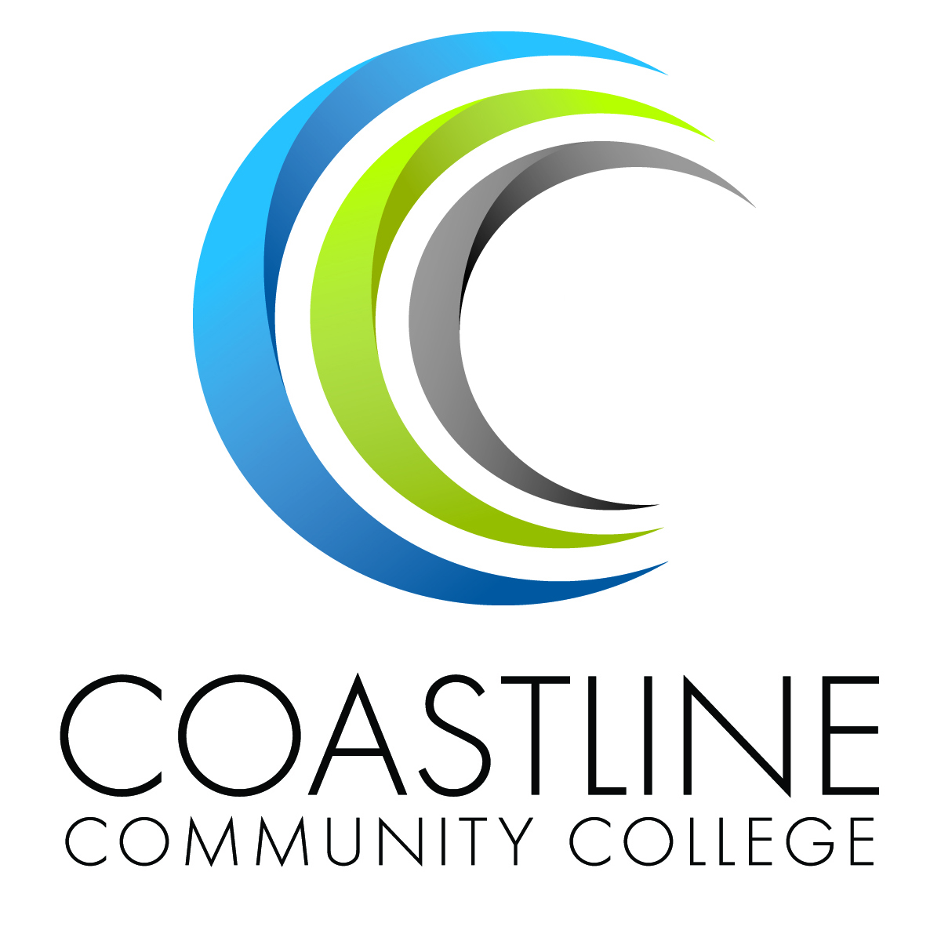 | COASTLINE COMMUNITY COLLEGE  BUDGET DEVELOPMENT – FY 2012/2013  Resource Allocation Proposal
 |  | Administrator Use:

Originator:
Program or Department Name:
Area Dean:
Area Vice President:
Account Code:
Total Amount Requested:
One-Time Funding:
On-Going Funding:
Department Priority Ranking: |  | of

What are you requesting? Why is the request being made? Where was the need identified?

Demonstrate how your request is supported by your a) Program Review/Annual Program Assessment and b) Student Learning Outcome, Program Learning Outcome, Institutional Learning Outcome, Service Area Outcome or c) other planning documents.
a)

b)

c)

Describe your goal(s) for this proposal? How will this impact students or institutional services?

What are some measureable outcomes that demonstrate you met your goal(s)?

What are the steps that you will take or need to be taken to implement this proposal? (Implementation
Plan)

List other areas of compelling evidence that would support your proposal
Compliance

Health & Safety

Other

Describe how your request is aligned with the following Annual Institutional Goals.

Student Success

Access, Persistence & Completion:

Innovation & Improvement:

Partnerships

Culture of Planning, Inquiry & Evidence

Growth & Efficiency

Demonstrate how your proposal is supported by the 2011-16 Education Master Plan:

FOR ADMINISTRATOR USE

Demonstrate how this proposal is supported by your Unit OR Division Plan. Provide link to Unit/Division Plan.

Projected Expense Profile

New Personnel Request--This does not include Full Time Academic Faculty Positions.
For personnel requests please attach the job description, job classification and label "Exhibit I."
Position Title: Estimated Cost

1XXX Academic Salaries (Certificated)
3XXX Benefits* $0.00
Position Title: Estimated Cost

1XXX Academic Salaries (Certificated)
3XXX Benefits* $0.00
Position Title:
2XXX Classified/Non Academic Salaries 10, 11 or 12 Months
3XXX Benefits* Hours per Week $0.00
Position Title:
2XXX Classified/Non Academic Salaries 10, 11 or 12 Months
3XXX Benefits* Hours per Week $0.00
$0.00

Sub Total:

Non Personnel Requests:

Object Cod | Title |  | Amount  Requested
4XXX | Supplies and Materials
5XXX | Services
6XXX | New Equipment or Building/Site Improvements
 |  | Sub Total: | $ -

Total Budget Proposal:
$0.00

Secondary Effects (if this proposal is approved)

For Personnel Requests:

What additional space, if any, is needed to accommodate this position? If so, where is the proposed location?

For Equipment and Technology Request
Will additional space be needed to accommodate requested equipment? If so where is the proposed location?

Will requested equipment require maintenance agreements and or support personnel? If so what are the projected costs?

Please list future year anticipated needs and estimated financial needs. NOTE: This section refers to any anticipated funding not addressed by this RAP, but required in the future. This will not be automatically funded. A new RAP must be completed in future years.
Fiscal Year | Anticipated Need | Estimated Amount

Dean Approval Date Vice President Approval Date

COASTLINE COMMUNITY COLLEGE
PLANNING GUIDE
2012-2013
GLOSSARY OF TERMS

AA: Associate of Arts Degree
ACCJC: Accrediting Commission for Community and Junior Colleges of the Western Association of Schools and Colleges
ALO: Accreditation Liaison Officer
ARCCC: Accountability Reporting for California Community Colleges
AS: Associate of Science Degree
CCC: Coastline Community College
CPEC: California Postsecondary Education Commission
CSLO: Course Student Learning Outcome
CTE: Career and Technical Education
DL: Distance Learning
ESL: English as a Second Language
FTEF: Full Time Equivalent Faculty
FTES: Full Time Equivalent Students
ISD: Instructional Systems Development (Coast Learning Systems)
Now OL&IT (Office of Learning & Information Technologies)
ISLO: Institutional Student Learning Outcome
LHE: Lecture Hour Equivalent
OL&IT: Office of Learning & Information Technologies
PIEAC: Planning, Institutional Effectiveness, and Accreditation Committee
PSLO: Program Student Learning Outcomes
SLO: Student Learning Outcomes
CSLOS: Course Student Learning Outcomes
ISLOS: Institutional Student Learning Outcomes
PSLOs: Program Student Learning Outcomes
SLOs: Student Learning Outcomes
SSTF: Student Success Task Force [State Chancellor’s Office]
STEM: Science, Technology, Engineering, & Mathematics
WASC: Western Association of Schools and Colleges
WSCH: Weekly Student Contact Hour

